CS 340 Project Two
Readme

Tammy Wilson
Southern New Hampshire University
CS 340: Client/Server Development
Instructor: Hari Pruchuri
April 19, 2026

ReadMe

1.Overview
This project implements an interactive data dashboard for Grazioso Salvare, an organization specializing in training rescue dogs for water rescue, mountain/wilderness rescue, and disaster/individual tracking operations. The dashboard provides a clear, user-friendly interface that allows the client to explore animal shelter data, filter animals by rescue category, and visualize trends through charts and maps.
The goal of this dashboard is to help the client quickly identify animals that meet specific rescue criteria and support data-driven decision-making.
2.Tools and Technologies used
- Python 3
- Dash / JupyterDash – Web application framework for interactive dashboards
- Dash DataTable – Interactive table with sorting, filtering, and row selection
- Plotly Express – Data visualization (bar charts)
- Dash Leaflet – Map visualization
- Pandas – Data manipulation and filtering
- MongoDB – Backend database for CRUD operations
- Custom CRUD Python Module – Manages database authentication and read operations.
3. How dashboard works:
The dashboard is composed of four main components:
- Rescue Category Filter (Dropdown Menu)
Users can select one of the following options:
- Reset (All Animals)
- Water Rescue
- Mountain/Wilderness Rescue
- Disaster/Individual Tracking
When a rescue type is selected, the dashboard runs a MongoDB query through the CRUD module and updates the table and visualizations accordingly.
- Interactive Data Table
The DataTable supports:
- Sorting
- Filtering
- Pagination
- Single-row selection
The table updates automatically based on the rescue filter. If no animals match a rescue category, the table displays no rows while remaining fully functional.
Screenshot: 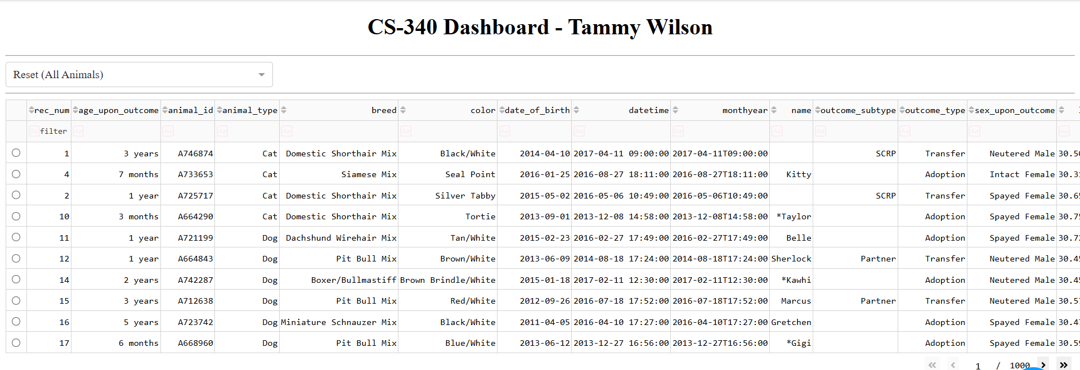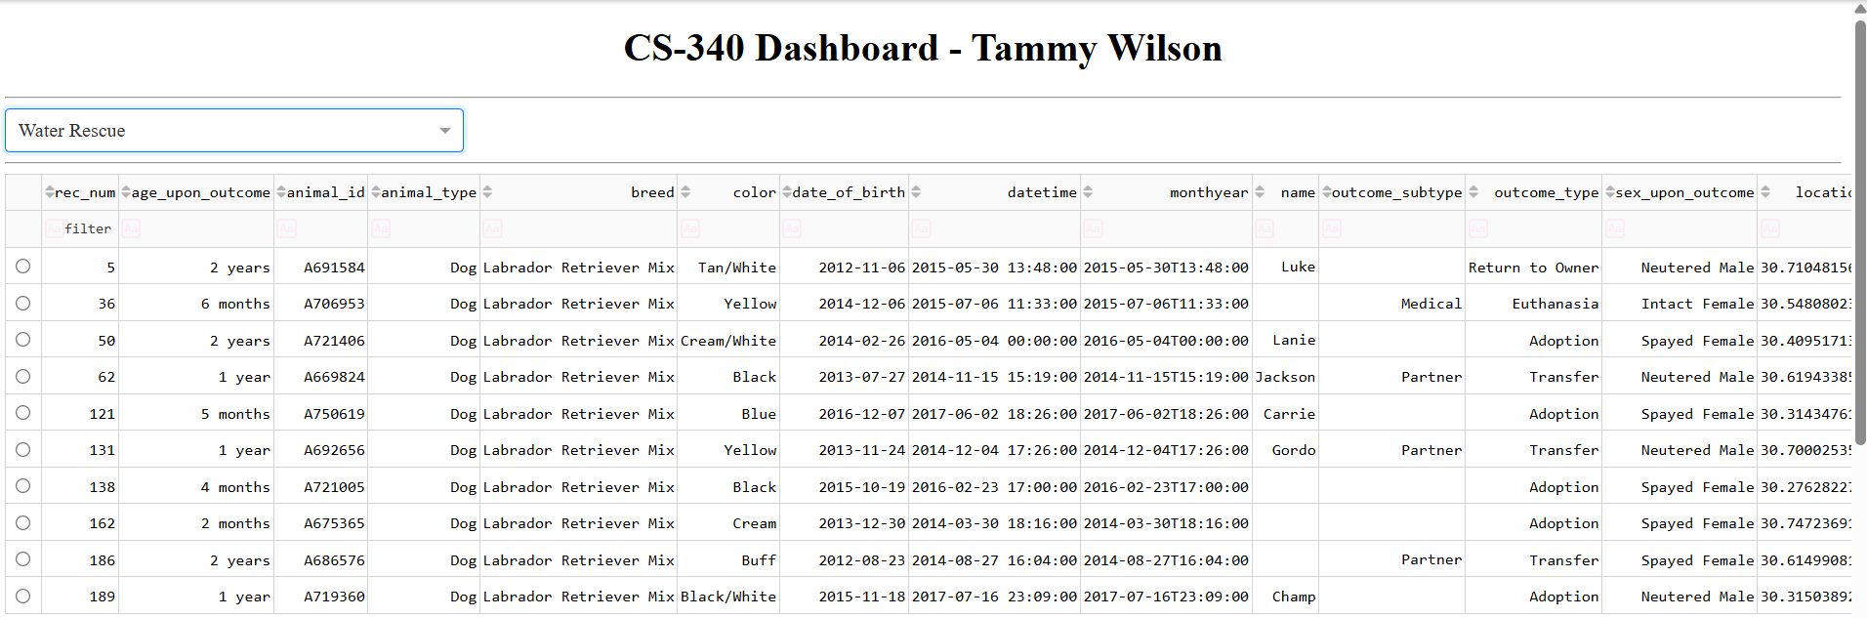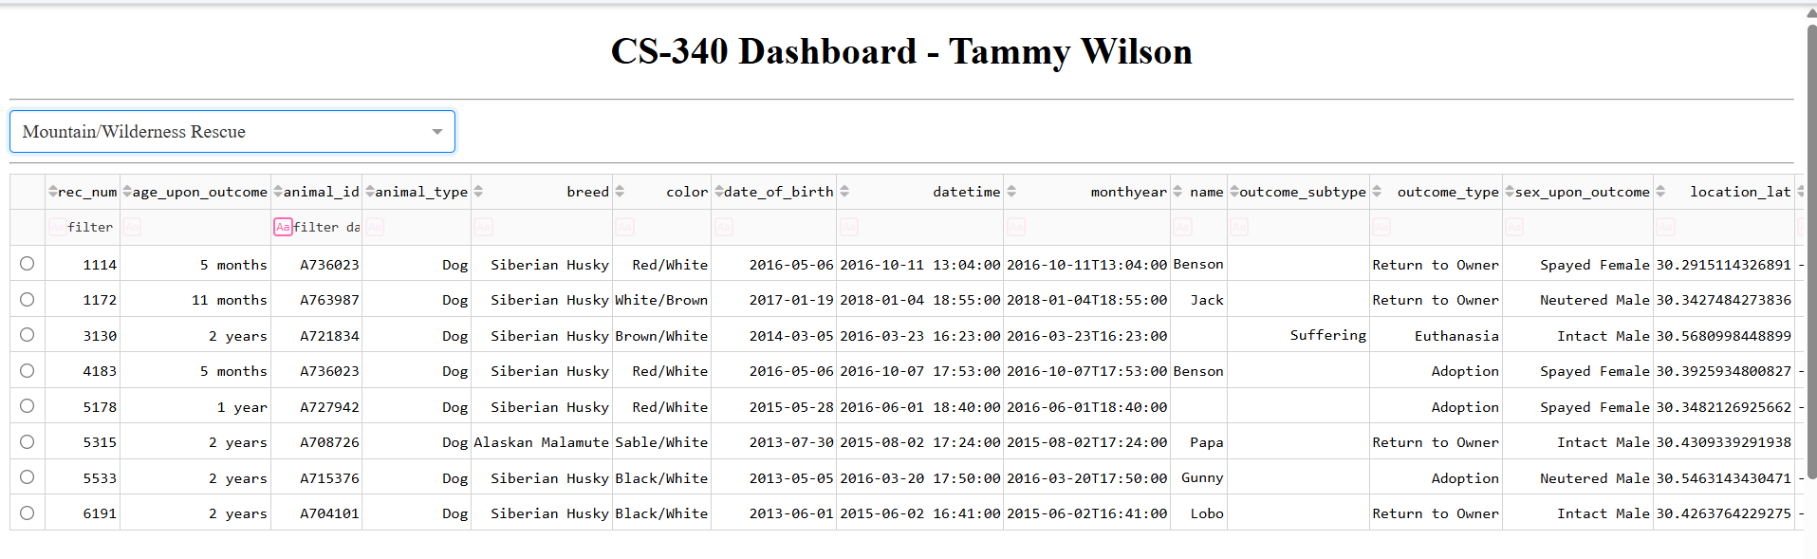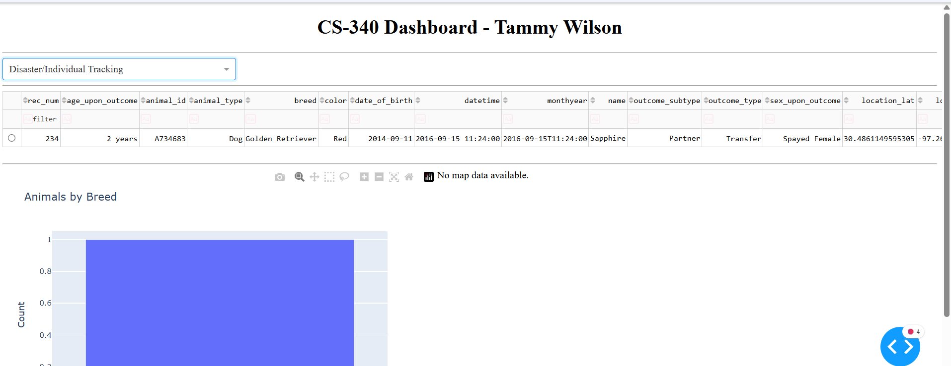

- Bar Chart — “Animals by Breed”
The bar chart dynamically updates based on the data currently displayed in the table. It counts how many animals belong to each breed and presents the results visually.
This helps the client quickly identify which breeds appear most frequently in the filtered dataset.

Screenshot:
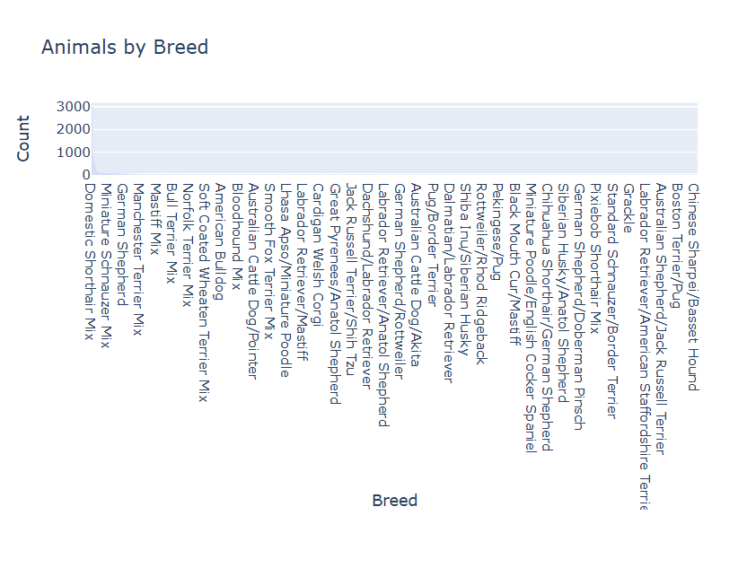
- Map Visualization
The map component is designed to show the geographic location of the selected animal. Because the provided dataset does not include latitude or longitude fields, the dashboard includes graceful fallback behavior:
- If geolocation columns are missing, the map displays a message instead of crashing.
- This ensures the dashboard remains stable and user-friendly.

Screenshot:
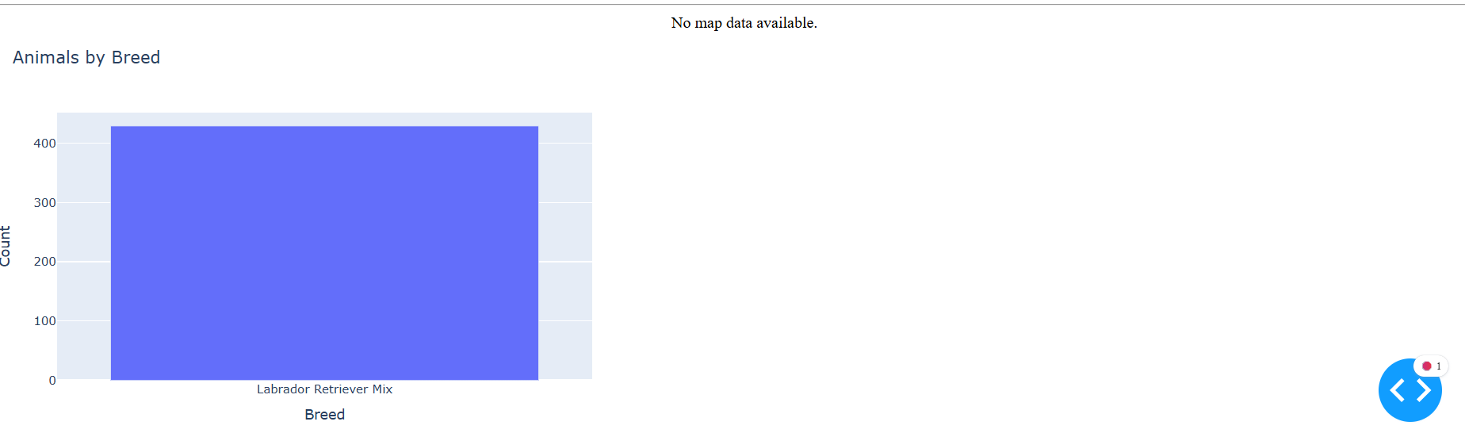

4.Filter Logic
Each rescue category uses a specific MongoDB query to identify suitable animals. The queries filter by:
- Animal type (Dog)
- Breed (based on rescue suitability)
- Age (converted to weeks)
The dashboard uses a helper function (get_rescue_data()) to run these queries and return the filtered dataset.

5.System Architecture
The dashboard follows a clear MVC-style structure:
- Model: MongoDB database accessed through the CRUD Python module.
- View: Dash layout containing the DataTable, dropdown, bar chart, and map.
- Controller: Dash callbacks that update the table, chart, and map based on user interaction.
This separation ensures maintainability and clarity.

6. Challenges and how they were resolved

Missing Geolocation Data
The dataset did not include location_lat or location_long fields required for the map. To prevent callback failures, the map callback was updated to:
- Detect missing columns
- Display a friendly message instead of crashing.

Case Sensitivity in Column Names
The bar chart initially failed because the dataset used lowercase breed, while the code expected Breed. A case-insensitive column-matching function was added to ensure reliability.

Empty Query Results
Some rescue filters returned zero animals. The DataTable callback was updated to safely manage empty datasets without breaking the dashboard.

7. How to run Dashboard
- Launch JupyterLab in Codio.
- Open ProjectTwoDashboard.ipynb.
- Run all cells in order.
- The dashboard will open at: http://localhost:8050 (or the Codio proxy URL).
- Use the dropdown to filter animals and explore the visualizations.

8. Conclusion
This dashboard provides Grazioso Salvare with a powerful, interactive tool for exploring animal shelter data and identifying potential rescue dogs. The combination of filtering, visualization, and database integration supports efficient decision-making and aligns with the organization’s operational needs.

